aim games  
Sprint 3 Planning

# Summons

|  |  |
| --- | --- |
| Name | Roll |
| De la Fuente Bonilla, Fco. Javier | **CEO, Project manager** |
| Molina Domínguez, Jorge Manuel | **CCO, CIO** |
| Bizcocho González, Mario | **CMO, Product Owner** |
| Arenas Arenas, Antonio  Monteseirín Puig, Alejandro  Pazo Jiménez, Pablo  Pérez Piñero, Iván  Santos Batista, Miguel | **Developers** |

# attendee

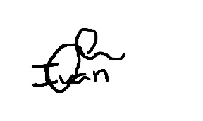**De la Fuente Bonilla, Fco. Javier Pérez Piñero, Iván**

**Arenas Arenas, Antonio Molina Domínguez, Jorge Manuel**

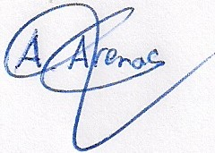

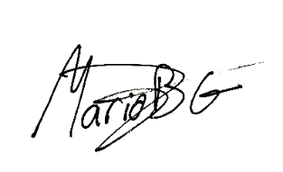**Monteseirín Puig, Alejandro Bizcocho González, Mario**

**Santos Batista, Miguel Pazo Jiménez, Pablo**

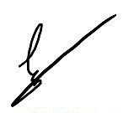

# Absent

No Proceed

# Date and place

Being on Saturday April 20, 2019, and verified the attendance of all the summoned, began at 17:00 hrs. To the Sprint 3 planning for the AIM GAMES project, which ended at 18:00 hrs.

# AGENDA

1º Planning of the 3º sprint

# Development of the meeting and agreements

## Planning of the 3º sprint

At the start, every member proposed his ideas After the personal study of the feedback during the holy week,

After studying all the propositions, we discussed and voted them and created the sprint backlog.

We decided to have the review at the next Friday 26, April.

# Signed in conformity

